STATE ADVISORY COUNCIL FOR THE EARLY IDENTIFICATION OF HEARING IMPAIRED INFANTS
Quarterly Council Meeting
Baton Rouge, Louisiana
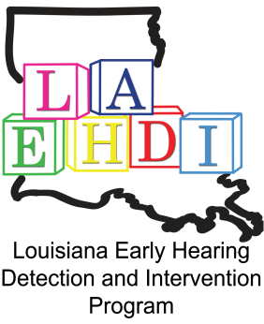

Friday, April 27, 2018
9am-12pm
AGENDA

- Call to Order/Introduction of attendees
2. Review and Acceptance of Minutes
3. EHDI Program Updates
4. Review and Vote on Council Membership Attendance Requirements
Council vacancy updates
a. Pediatrician – in process
b. Neonatologist- in process
c. Parent of a deaf or hard of hearing child utilizing
Total Communication

8. Hands & Voices GBYS Update – Deaf and Hard of Hearing Guides

Break

9. Subcommittee Presentations
° CMV –
° Brochure Committee

10. Next Council meeting date

